Lab Assignment
- Write a program with indexed addressing that calculates the sum of all the gaps between array elements. The array elements are word type, sequenced in non-decreasing order. Use the value array {0,2,5,9,10}. These values has a gaps of 2,3,4, and 1 which the total of 10.

Example Output:

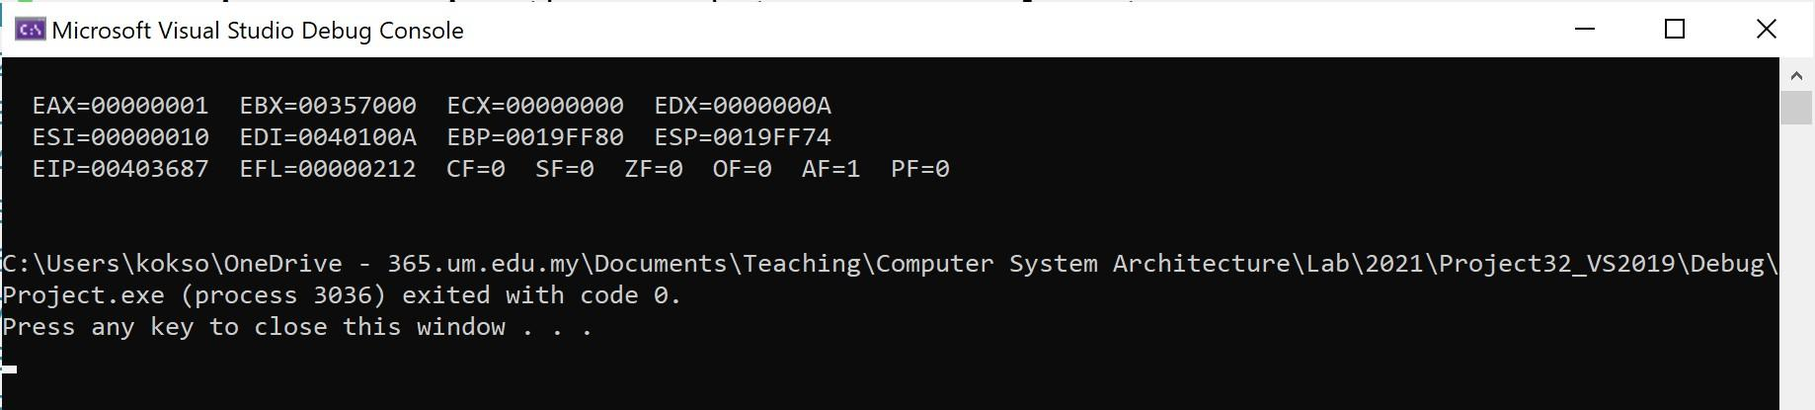

section .data

; The array elements are word type (16-bit)

array dw 0, 2, 5, 9, 10

array_len equ ($ - array) / 2

msg db "Sum of gaps: "

msg_len equ $ - msg

newline db 10

section .bss

char_buffer resb 2 ; Buffer to hold the 2-digit string output

section .text

global _start

_start:

mov rsi, array ; Load address of the array into rsi

mov rcx, array_len ; Loop counter

sub rcx, 1 ; We compare pairs, so we need length - 1 iterations

xor rax, rax ; Clear rax (will hold the running sum)

xor rbx, rbx ; Clear rbx

xor rdx, rdx ; Clear rdx

calc_loop:

movzx bx, word [rsi] ; Load current element (zero-extended to 64-bit)

movzx dx, word [rsi + 2] ; Load next element (zero-extended to 64-bit)

sub dx, bx ; Calculate gap: next - current

add eax, edx ; Add the gap to our running sum in eax

add rsi, 2 ; Move pointer 2 bytes forward (since it is a WORD array)

loop calc_loop ; Decrement rcx, jump if not zero

; At this point, eax contains the total sum (10).

; We must convert this integer into ASCII characters ('1' and '0') to print it.

mov rdi, char_buffer

mov rcx, 10

xor rdx, rdx

div rcx ; Divide eax by 10. Quotient goes to eax, remainder to edx.

add al, '0' ; Convert quotient (tens digit) to ASCII

mov [rdi], al ; Store in buffer

add dl, '0' ; Convert remainder (ones digit) to ASCII

mov [rdi+1], dl ; Store in buffer

; Syscall: Write "Sum of gaps: "

mov rax, 1

mov rdi, 1

mov rsi, msg

mov rdx, msg_len

syscall

; Syscall: Write the calculated ASCII number

mov rax, 1

mov rdi, 1

mov rsi, char_buffer

mov rdx, 2

syscall

; Syscall: Write newline

mov rax, 1

mov rdi, 1

mov rsi, newline

mov rdx, 1

syscall

; Syscall: Exit

mov rax, 60

xor rdi, rdi

syscall

Output
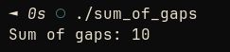

- Write an assembly code to generate a sequence of number when a number is initialized. Follow the below instruction:
  - Initialize a number which is 8.
  - Use all available register to perform an instruction that can generate a sequence of number 1,2,3,4,5,6,7,8,. The output should be like this:
1 2 3 4 5 6 7 8
2 3 4 5 6 7 8
3 4 5 6 7 8
4 5 6 7 8
5 6 7 8
6 7 8
7 8
8

Example Output:

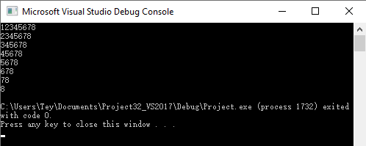
section .data

newline db 10

section .bss

char_buffer resb 1

section .text

global _start

_start:

mov r8, 1 ; Outer loop counter (represents the starting digit of the row)

mov r9, 8 ; The initialized maximum number

outer_loop:

cmp r8, r9 ; Check if we have printed all rows

jg end_prog

mov r10, r8 ; Inner loop counter (starts at the current row's starting digit)

inner_loop:

cmp r10, r9 ; Check if we have reached 8 in the current row

jg print_newline

; Convert integer to ASCII and store in buffer

mov al, r10b

add al, '0'

mov [char_buffer], al

; Syscall: Write the character

; Note: We must preserve our loop registers (r8, r9, r10) by pushing them to the stack

; because syscalls can alter standard registers.

mov rax, 1

mov rdi, 1

mov rsi, char_buffer

mov rdx, 1

push r8

push r9

push r10

syscall

pop r10

pop r9

pop r8

inc r10 ; Increment inner loop

jmp inner_loop

print_newline:

; Syscall: Write newline at the end of the row

mov rax, 1

mov rdi, 1

mov rsi, newline

mov rdx, 1

push r8

push r9

syscall

pop r9

pop r8

inc r8 ; Increment outer loop to start the next row

jmp outer_loop

end_prog:

; Syscall: Exit cleanly

mov rax, 60

xor rdi, rdi

syscall
Output
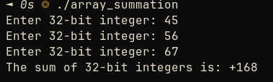

3. Write a program that prompts the user for three 32-bit integers stores them in an array, calculates the sum of the array, and displays the sum on the screen.

Example Output:

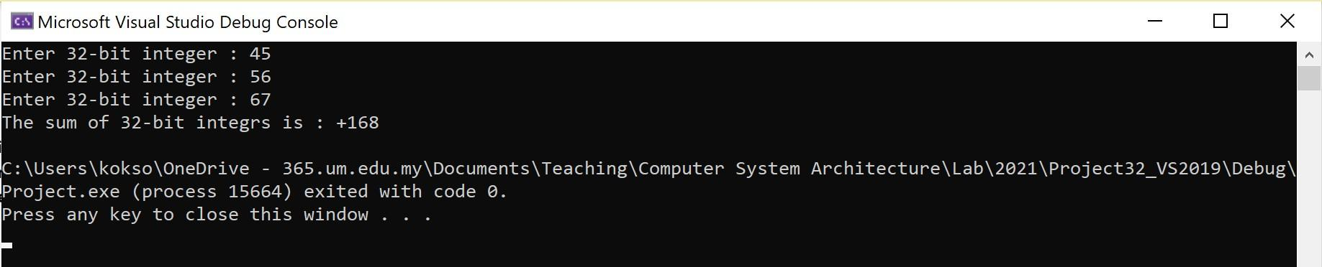
section .data
prompt db "Enter 32-bit integer: ", 0
prompt_len equ $ - prompt
result_msg db "The sum of 32-bit integers is: +", 0
result_len equ $ - result_msg
newline db 10

section .bss
input_buffer resb 32 ; Buffer for raw keyboard input
array resq 3 ; Array to store 3 64-bit integers (quadwords)
output_buffer resb 32 ; Buffer for integer-to-string conversion

section .text
global _start

_start:
mov r12, 0 ; r12 will be our array index counter (0 to 2)

input_loop:
cmp r12, 3 ; Have we collected 3 integers?
je calculate_sum

; --- 1. Print Prompt ---
mov rax, 1
mov rdi, 1
mov rsi, prompt
mov rdx, prompt_len
syscall

; --- 2. Read Input ---
mov rax, 0 ; sys_read
mov rdi, 0 ; standard input
mov rsi, input_buffer
mov rdx, 32 ; read up to 32 bytes
syscall

; --- 3. Convert ASCII to Integer (atoi) ---
mov rsi, input_buffer ; pointer to the string
xor rax, rax ; rax will hold the resulting integer
xor rcx, rcx ; clear rcx for byte extraction

atoi_loop:
mov cl, byte [rsi] ; load next byte
cmp cl, 10 ; check for newline (Enter key)
je store_in_array
cmp cl, 0 ; check for null terminator
je store_in_array

sub cl, '0' ; convert ASCII character to raw number (e.g., '5' - '0' = 5)
imul rax, 10 ; multiply current accumulator by 10
add rax, rcx ; add the new digit

inc rsi ; move to next character
jmp atoi_loop

store_in_array:
; Store the parsed binary integer into the array
; r12 is the index (0, 1, 2). Multiply by 8 because each integer is 8 bytes (64-bit).
mov [array + r12*8], rax
inc r12
jmp input_loop

calculate_sum:
; --- 4. Sum the Array ---
xor rax, rax ; rax will hold the sum
mov r12, 0 ; reset index

sum_loop:
cmp r12, 3
je print_result_prefix
add rax, [array + r12*8] ; add array element to sum
inc r12
jmp sum_loop

print_result_prefix:
; Save the sum (rax) to stack before syscalls destroy it
push rax

; Print "The sum is: +"
mov rax, 1
mov rdi, 1
mov rsi, result_msg
mov rdx, result_len
syscall

pop rax ; Restore the sum into rax

; --- 5. Convert Integer back to ASCII String (itoa) ---
mov rsi, output_buffer ; pointer to end of buffer (we build string backwards)
add rsi, 31 ; start near the end of the 32-byte buffer
mov byte [rsi], 0 ; null-terminate the string
mov rcx, 10 ; divisor for base 10

itoa_loop:
xor rdx, rdx ; clear rdx before division
div rcx ; rax / 10. Quotient in rax, remainder in rdx.
add dl, '0' ; convert remainder to ASCII character
dec rsi ; move pointer back one byte
mov [rsi], dl ; store character

test rax, rax ; is quotient zero?
jnz itoa_loop ; if not, keep dividing

; --- 6. Print the Converted String ---
; rsi now points to the beginning of our generated ASCII string
mov rdi, rsi ; save string pointer

; calculate length of generated string
mov r8, output_buffer
add r8, 31
sub r8, rsi ; r8 now contains string length

mov rax, 1
mov rdx, r8 ; length
mov rsi, rdi ; pointer
mov rdi, 1 ; stdout
syscall

; --- 7. Print Newline and Exit ---
mov rax, 1
mov rdi, 1
mov rsi, newline
mov rdx, 1
syscall

mov rax, 60
xor rdi, rdi
syscall
Output


4. Create a procedure that receives an integer value between 0 and 100. Then, display a single capital letter on the screen. The letter returned by the procedure should be according to the following ranges.
90 to 100 A
80 to 89 B
70 to 79 C
60 to 69 D
0 to 59 F

Example Output:

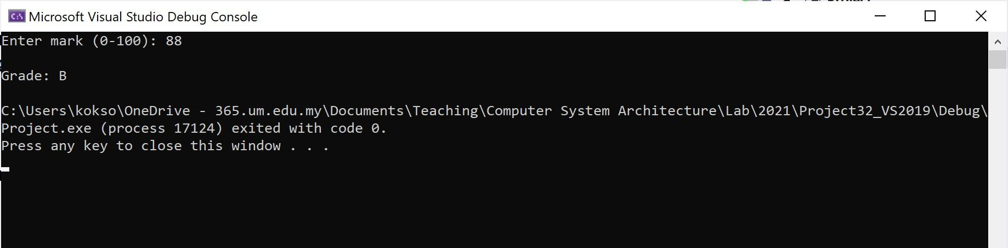
section .data

prompt db "Enter mark (0-100): ", 0

prompt_len equ $ - prompt

result_msg db "Grade: ", 0

result_len equ $ - result_msg

newline db 10

; Define grade characters

grade_A db "A", 10

grade_B db "B", 10

grade_C db "C", 10

grade_D db "D", 10

grade_F db "F", 10

section .bss

input_buffer resb 8

section .text

global _start

_start:

; --- 1. Print Prompt ---

mov rax, 1

mov rdi, 1

mov rsi, prompt

mov rdx, prompt_len

syscall

; --- 2. Read Input ---

mov rax, 0

mov rdi, 0

mov rsi, input_buffer

mov rdx, 8

syscall

; --- 3. Convert ASCII to Integer ---

mov rsi, input_buffer

xor rax, rax

xor rcx, rcx

parse_loop:

mov cl, byte [rsi]

cmp cl, 10

je evaluate_grade

cmp cl, 0

je evaluate_grade

sub cl, '0'

imul rax, 10

add rax, rcx

inc rsi

jmp parse_loop

evaluate_grade:

; --- 4. Print Result Prefix ("Grade: ") ---

push rax ; save parsed integer score

mov rax, 1

mov rdi, 1

mov rsi, result_msg

mov rdx, result_len

syscall

pop rax ; restore score into rax

; --- 5. Comparison Logic ---

cmp rax, 90

jge assign_A

cmp rax, 80

jge assign_B

cmp rax, 70

jge assign_C

cmp rax, 60

jge assign_D

jmp assign_F ; If it's less than 60, it's an F

assign_A:

mov rsi, grade_A

jmp print_grade

assign_B:

mov rsi, grade_B

jmp print_grade

assign_C:

mov rsi, grade_C

jmp print_grade

assign_D:

mov rsi, grade_D

jmp print_grade

assign_F:

mov rsi, grade_F

jmp print_grade

print_grade:

; --- 6. Print the Grade Character and Exit ---

; rsi already points to the correct character (which includes a newline)

mov rax, 1

mov rdi, 1

mov rdx, 2 ; 1 byte for char, 1 byte for newline

syscall

mov rax, 60

xor rdi, rdi

syscall
